Then in the following image we can see the usual processes involved in Oracle RAC as well as the different levels of execution in the operating system from the beginning of the same (level 0) to the levels that control system resources.

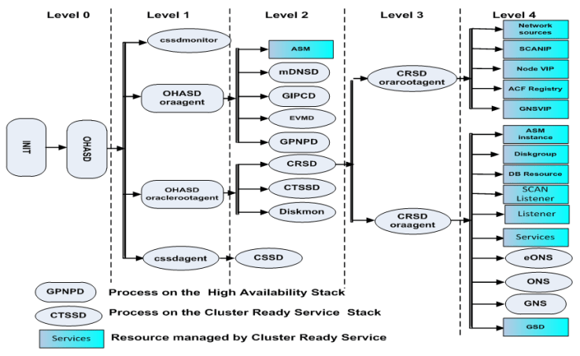

**Below are the Oracle 19C RAC pre-requistes :-**

* Hardware Requirements.
* Network Hardware Requirements.
* IP Address Requirements.
* OS and software Requirements.
* Preparing the server to install Grid Infrastructure.

**Hardware Requirements: -**

* RAM -40GB
* Swap-40GB
* CPU's-8

**Mount points:-**

* /u01-100GB--->GRID_HOME
* /u02-100GB--->ORACLE_HOME
* /tmp-10GB

**Create the Oracle Inventory Directory:-**

* mkdir -p /u01/app/oraInventory
* chown -R grid:oinstall /u01/app/oraInventory
* chmod -R 775 /u01/app/oraInventory

**Creating the Oracle Grid Infrastructure Home Directory:-**

* mkdir -p /u01/19.3.0/grid_home
* chown -R grid:oinstall /u01/19.3.0.0/grid_home
* chmod -R 775 /u01/19.3.0.0/grid_home

**Creating the Oracle Base Directory:-**

* mkdir -p /u01/app/oracle
* mkdir /u01/app/oracle/cfgtoollogs –needed to ensure that dbca is able to run after the rdbms installation.
* chown -R oracle:oinstall /u01/app/oracle
* chmod -R 775 /u01/app/oracle

**Creating the Oracle RDBMS Home Directory:-**

* mkdir -p /u01/app/oracle/product/19.3.0.0/db_home
* chown -R oracle:oinstall /u01/app/oracle/product/19.3.0.0/db_home
* chmod -R 775 /u01/app/oracle/product/19.3.0.0/db_home

**Network Hardware Requirements:-**

* Each node must have at least two network interface cards (NIC), or network adapters. One adapter is for the public network interface and the other adapter is for the private network interface (interconnect).
* Public interface names must be the same for all nodes. If the public interface on one node uses the network adapter eth0, then you must configure eth0 as the public interface on all nodes.
* You should configure the same private interface names for all nodes as well. If eth1 is the private interface name for the first node, then eth1 should be the private interface name for your second node.
* The private network adapters must support the user datagram protocol (UDP) using high-speed network adapters and a network switch that supports TCP/IP (Gigabit Ethernet or better). Oracle recommends that you use a dedicated network switch.

**IP Address Requirements:-**

* A public IP address for each node
* A virtual IP address for each node
* Three single client access name (SCAN) addresses for the cluster
* Private IP address for each node

**OS and software Requirements:-**

* Red Hat Enterprise Linux Server release 7.6 (Maipo)

**Synchronize the time between each RAC nodes:-**

* Oracle Clusterware 19c release requires time synchronization across all nodes within a cluster when Oracle RAC is deployed. Configure the NTP for both server (time should be match).

**User,group creation and permissions:-**

* groupadd -g 54321 oinstall
* groupadd -g 54322 dba
* groupadd -g 54323 oper
* groupadd -g 54324 asmdba
* groupadd -g 54325 asmoper
* groupadd -g 54326 asmadmin
* useradd -u 54321 -g oinstall -G dba,oper oracle
* useradd -u 54321 -g oinstall
* -G dba,oper,asmdba,asmoper, asmadmin grid
* chown -R oracle:oinstall /u02/app/oracle/product/19.3.0.0/db_home
* chown -R grid:oinstall /u01/app/grid/19.3.0.0/grid_home
* chmod -R 775 /u02/oracle/prod
* chmod -R 775 /u01/oracle/grid

**OS RPMS for RHEL 7.6 :-**

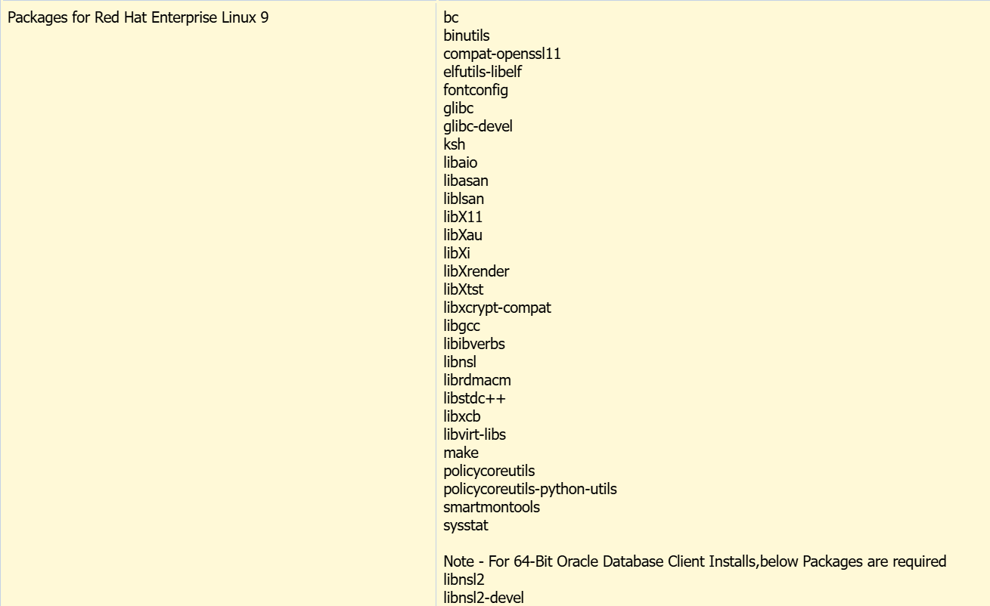

* oracle-database-server-19cR2-preinstall
* binutils
* compat-libstdc++-33
* compat-libstdc++-33.i686
* gcc
* gcc-c++
* glibc
* glibc.i686
* glibc-devel
* glibc-devel.i686
* ksh
* libgcc
* libgcc.i686
* libstdc++
* libstdc++.i686
* libstdc++-devel
* libstdc++-devel.i686
* libaio
* libaio.i686
* libaio-devel
* libaio-devel.i686
* libXext
* libXext.i686
* libXtst
* libXtst.i686
* libX11
* libX11.i686
* libXau
* libXau.i686
* libxcb
* libxcb.i686
* libXi
* libXi.i686
* make
* sysstat
* unixODBC
* unixODBC-devel
* zlib-devel
* zlib-devel.i686
* oracleasmlib-2.0.12-1.el7.x86_64.rpm
* oracleasmlib-2.0.4-1.el6.x86_64.rpm
* oracleasm-support-2.1.11-2.el7.x86_64.rpm
* kmod-oracleasm-2.0.8-21.0.1.el7.x86_64.rpm
* oracle-database-preinstall-19c-1.0-1.el7.x86_64.rpm
* libXaw-1.0.13-4.el7.x86_64.rpm
* xorg-x11-apps-7.7-7.el7.x86_64.rpm
* compat-libcap1-1.10-7.el7.x86_64.rpm
* oracle-database-ee-19c-1.0-1.x86_64.rpm
* cvuqdisk-1.0.10-1.rpm
* rpm -qa|grep libdtrace-ctf
* rpm -qa|grep libdtrace-ctf-devel
* rpm -qa|grep dtrace-utils
* rpm -qa|grep dtrace-utils-devel

**Kernel Parameter:**-

* vi /etc/sysctl.conf

* fs.file-max = 6815744
* kernel.sem = 250 32000 100 128
* kernel.shmmni = 4096
* kernel.shmall = 1073741824
* kernel.shmmax = 4398046511104
* net.core.rmem_default = 262144
* net.core.rmem_max = 4194304
* net.core.wmem_default = 262144
* net.core.wmem_max = 1048576
* fs.aio-max-nr = 1048576
* net.ipv4.ip_local_port_range = 9000 65500
* kernel.panic_on_oops = 1

**Security Parameter:-**

* vi /etc/security/limits.conf

* oracle soft nofile 131072
* oracle hard nofile 131072
* oracle soft nproc 131072
* oracle hard nproc 131072
* oracle soft core unlimited
* oracle hard core unlimited
* oracle soft stack 10240
* oracle hard stack 32768
* oracle hard memlock 134217728
* oracle soft memlock 134217728
* grid soft nofile 131072
* grid hard nofile 131072
* grid soft nproc 131072
* grid hard nproc 131072
* grid soft core unlimited
* grid hard core unlimited
* grid soft stack 10240
* grid hard stack 32768
* grid hard memlock 134217728
* grid soft memlock 134217728

**Rp_filter:-**

* sysctl -a | grep '\.rp_filter'
* net.ipv4.conf.all.rp_filter = 2
* net.ipv4.conf.default.rp_filter = 2
* net.ipv4.conf.ens192.rp_filter = 1
* net.ipv4.conf.ens224.rp_filter = 2
* net.ipv4.conf.lo.rp_filter = 0

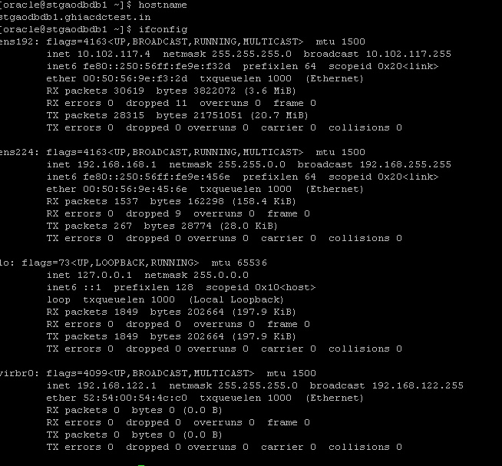

Need install oracle rpms prerequities.

Need sudo access to appadmin, oracle and grid users.

Required password less connection between two servers for oracle and grid users.

Login with oracle user

we need to get 7ips from server team (2 private ips’s,2 virtual ip’s,3 scan ips)

after getting complete ips follow as below

open vi /etc/hosts and enter below details

127.0.0.1 localhost localhost.localdomain localhost4 localhost4.localdomain4

::1 localhost localhost.localdomain localhost6 localhost6.localdomain6

#################### PUBLIC IPs ##############################################

10.102.117.4 stgaodbdb1.ghiacdctest.in stgaodbdb1

10.102.117.4 node1

10.102.117.5 stgaodbdb2.ghiacdctest.in stgaodbdb2

10.102.117.5 node2

#################### PRIVATE IPs ##############################################

192.168.168.1 stgaodbdb1-priv.ghiacdctest.in stgaodbdb1-priv

192.168.168.2 stgaodbdb2-priv.ghiacdctest.in stgaodbdb2-priv

#################### VIRTUAL IPs ##############################################

10.102.117.6 stgaodbdb1-vip.ghiacdctest.in stgaodbdb1-vip

10.102.117.7 stgaodbdb2-vip.ghiacdctest.in stgaodbdb2-vip

#################### SCAN IPs ##############################################

10.102.117.8 stgaodbdb-scan.ghiacdctest.in stgaodbdb-scan

10.102.117.9 stgaodbdb-scan.ghiacdctest.in stgaodbdb-scan

10.102.117.10 stgaodbdb-scan.ghiacdctest.in stgaodbdb-scan

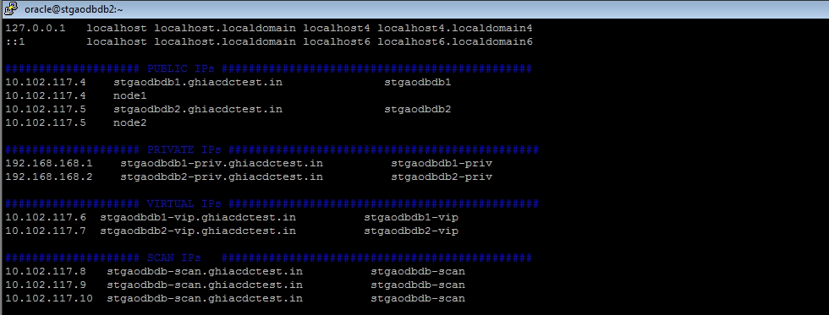

/u02 with 80GB

/grid_home with 65GB

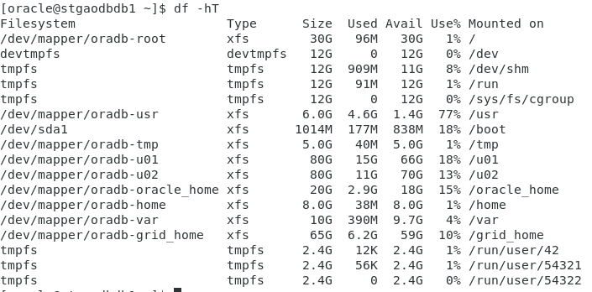

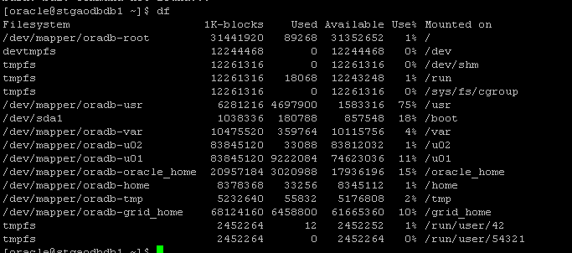

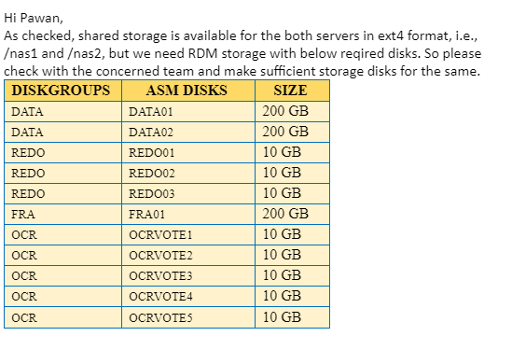

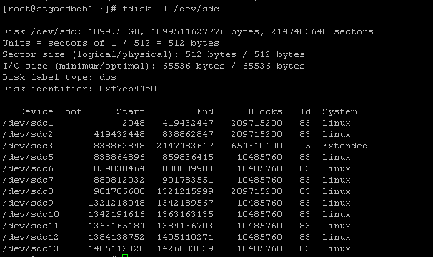

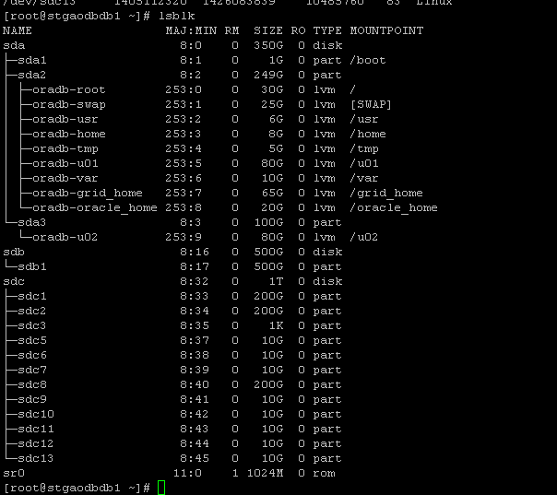

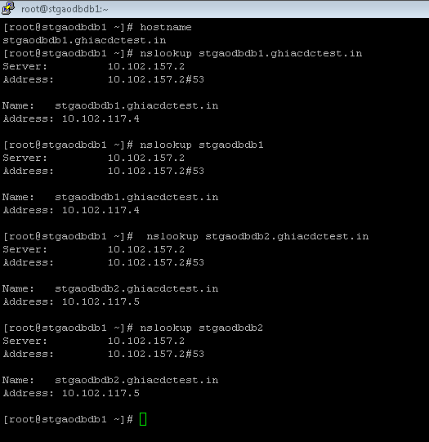

1. Login as oracle user
2. Switch to root user
3. Go to U01 directory
4. Follow below steps

**mkdir -p /u01/app/grid/19.3.0/grid_home1**

**mkdir -p /u01/app/oracle**

**mkdir -p /u01/app/oraInventory**



chown -R grid.oinstall /u01

chmod -R 755 /u01

check cat /etc/security

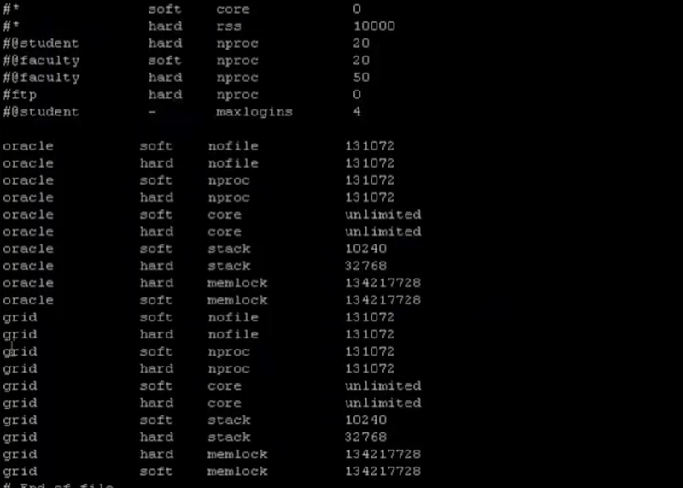

5) vi /etc/profile and copy the content in both the servers

######################### RAC PROFILE FOR ORACLE & GRID USERS #################

if [ $USER = "oracle" ]; then

if [ $SHELL = "/bin/ksh" ]; then

ulimit -p 16384

ulimit -n 65536

else

ulimit -u 16384 -n 65536

fi

fi

if [ $USER = "grid" ]; then

if [ $SHELL = "/bin/ksh" ]; then

ulimit -p 10240

ulimit -n 65536

else

ulimit -u 10240 -n 65536

fi

fi

6) Now check and don’t do any changes In it

vi /etc/sysctl.conf

# sysctl settings are defined through files in

# /usr/lib/sysctl.d/, /run/sysctl.d/, and /etc/sysctl.d/.

#

# Vendors settings live in /usr/lib/sysctl.d/.

# To override a whole file, create a new file with the same in

# /etc/sysctl.d/ and put new settings there. To override

# only specific settings, add a file with a lexically later

# name in /etc/sysctl.d/ and put new settings there.

#

# For more information, see sysctl.conf(5) and sysctl.d(5).

#

# oracle-database-preinstall-19c setting for fs.file-max is 6815744

fs.file-max = 6815744

# oracle-database-preinstall-19c setting for kernel.sem is '250 32000 100 128'

kernel.sem = 250 32000 100 128

# oracle-database-preinstall-19c setting for kernel.shmmni is 4096

kernel.shmmni = 4096

# oracle-database-preinstall-19c setting for kernel.shmall is 1073741824 on x86_64

kernel.shmall = 1073741824

# oracle-database-preinstall-19c setting for kernel.shmmax is 4398046511104 on x86_64

kernel.shmmax = 4398046511104

# oracle-database-preinstall-19c setting for kernel.panic_on_oops is 1 per Orabug 19212317

kernel.panic_on_oops = 1

# oracle-database-preinstall-19c setting for net.core.rmem_default is 262144

net.core.rmem_default = 262144

# oracle-database-preinstall-19c setting for net.core.rmem_max is 4194304

net.core.rmem_max = 4194304

# oracle-database-preinstall-19c setting for net.core.wmem_default is 262144

net.core.wmem_default = 262144

# oracle-database-preinstall-19c setting for net.core.wmem_max is 1048576

net.core.wmem_max = 1048576

# oracle-database-preinstall-19c setting for net.ipv4.conf.all.rp_filter is 2

net.ipv4.conf.all.rp_filter = 2

# oracle-database-preinstall-19c setting for net.ipv4.conf.default.rp_filter is 2

net.ipv4.conf.default.rp_filter = 2

# oracle-database-preinstall-19c setting for fs.aio-max-nr is 1048576

fs.aio-max-nr = 1048576

# oracle-database-preinstall-19c setting for net.ipv4.ip_local_port_range is 9000 65500

net.ipv4.ip_local_port_range = 9000 65500

7)change only hosts in the below file

vi /etc/nsswitch.conf

# Example:

#passwd: db files nisplus nis

#shadow: db files nisplus nis

#group: db files nisplus nis

passwd: files sss

shadow: files sss

group: files sss

#initgroups: files sss

#hosts: db files nisplus nis dns

#hosts: files dns myhostname

hosts: dns files nis

# Example - obey only what nisplus tells us...

#services: nisplus [NOTFOUND=return] files

#networks: nisplus [NOTFOUND=return] files

#protocols: nisplus [NOTFOUND=return] files

#rpc: nisplus [NOTFOUND=return] files

#ethers: nisplus [NOTFOUND=return] files

#netmasks: nisplus [NOTFOUND=return] files

bootparams: nisplus [NOTFOUND=return] files

ethers: files

netmasks: files

networks: files

protocols: files

rpc: files

services: files sss

netgroup: nisplus sss

publickey: nisplus

automount: files nisplus sss

aliases: files nisplus

8)check whether oracle username is having same groups or not in both servers using below command

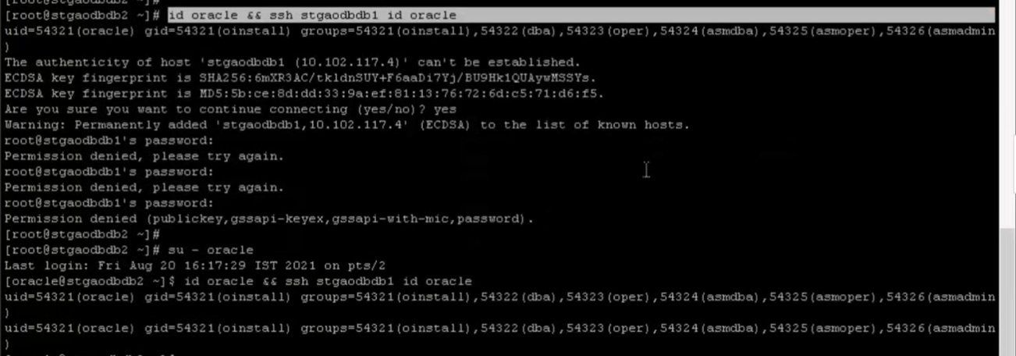

9)Check whether grid user is having same groups or not in both users using below command

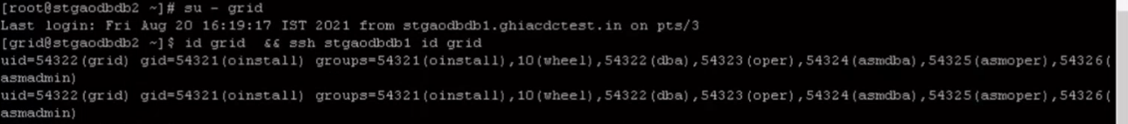

10)use below command to check whether the server is in domain or not

Vi /etc/resolv.conf

# Generated by NetworkManager

search ghiacdctest.in

nameserver 10.102.157.2

nameserver 10.102.157.6

11)check pinging to servers with public and private ip’s ,hostnames ,full domain names using both oracle and grid users

12)copy below files in both the servers for oracle and grid users

Switch to oracle user and open vi .bash_profile In node1

# .bash_profile

# Get the aliases and functions

if [ -f ~/.bashrc ]; then

. ~/.bashrc

fi

# User specific environment and startup programs

PATH=$PATH:$HOME/.local/bin:$HOME/bin

export PATH

##ORACLE SETTINGS for Node1

export TMP=/tmp

export TMPDIR=$TMP

export ORACLE_HOSTNAME=stgaodbdb1.ghiacdctest.in

export ORACLE_UNQNAME=HYDAMSST1

export ORACLE_BASE=/u02/app/oracle

export DB_HOME=$ORACLE_BASE/product/19.3.0/dbhome_1

export ORACLE_HOME=$DB_HOME

export ORACLE_SID=AODBSTG

export ORACLE_TERM=xterm

export PATH=/usr/sbin:/usr/local/bin:$PATH

export PATH=$ORACLE_HOME/bin:$PATH:.

export LD_LIBRARY_PATH=$ORACLE_HOME/lib:/lib:/usr/lib

export CLASSPATH=$ORACLE_HOME/jlib:$ORACLE_HOME/rdbms/jlib

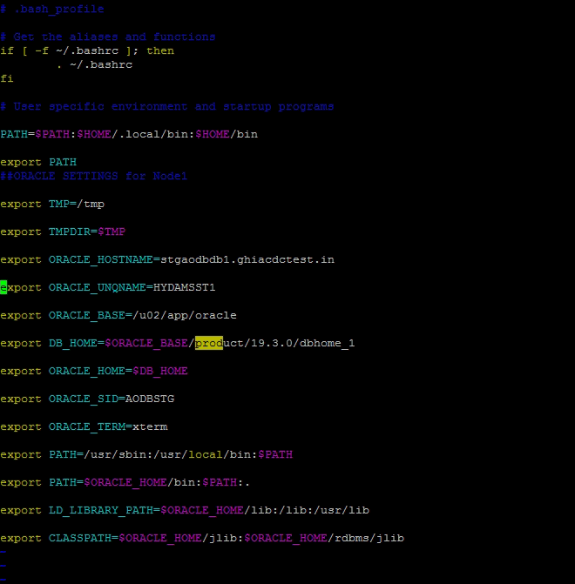

13)switch to grid user in node1 and open vi .bash_profile

copy below commands in it

# .bash_profile

# Get the aliases and functions

if [ -f ~/.bashrc ]; then

. ~/.bashrc

fi

# User specific environment and startup programs

PATH=$PATH:$HOME/.local/bin:$HOME/bin

export PATH

##GRID SETTINGS FOR Node1

export TMP=/tmp

export TMPDIR=$TMP

export ORACLE_HOSTNAME=stgaodbdb1.ghiacdctest.in

export ORACLE_BASE=/u01/app/oracle

export ORACLE_HOME=/u01/app/grid/19.3.0/grid_home1

export GRID_BASE=/u01/app/oracle

export GRID_HOME=/u01/app/grid/19.3.0/grid_home1

export ORACLE_SID=+ASM1

export ORACLE_TERM=xterm

export PATH=/usr/sbin:/usr/local/bin:$PATH

export PATH=$ORACLE_HOME/bin:$PATH

export LD_LIBRARY_PATH=$ORACLE_HOME/lib:/lib:/usr/lib

export CLASSPATH=$ORACLE_HOME/jlib:$ORACLE_HOME/rdbms/jlib

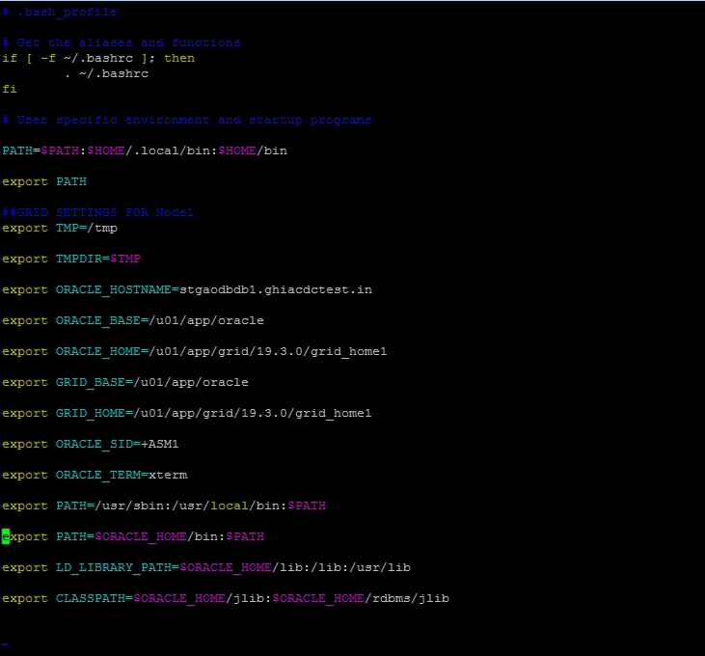

14)open secondary node

Login with oracle user and open vi .bash_profile

Copy below commands

# .bash_profile

# Get the aliases and functions

if [ -f ~/.bashrc ]; then

. ~/.bashrc

fi

# User specific environment and startup programs

PATH=$PATH:$HOME/.local/bin:$HOME/bin

export PATH

##ORACLE SETTINGS for Node2

export TMP=/tmp

export TMPDIR=$TMP

export ORACLE_HOSTNAME=stgaodbdb2.ghiacdctest.in

export ORACLE_UNQNAME=AODBSTG

export ORACLE_BASE=/u02/app/oracle

export DB_HOME=$ORACLE_BASE/product/19.3.0/dbhome_1

export ORACLE_HOME=$DB_HOME

export ORACLE_SID=AODBSTG

export ORACLE_TERM=xterm

export PATH=/usr/sbin:/usr/local/bin:$PATH

export PATH=$ORACLE_HOME/bin:$PATH:.

export LD_LIBRARY_PATH=$ORACLE_HOME/lib:/lib:/usr/lib

export CLASSPATH=$ORACLE_HOME/jlib:$ORACLE_HOME/rdbms/jlib

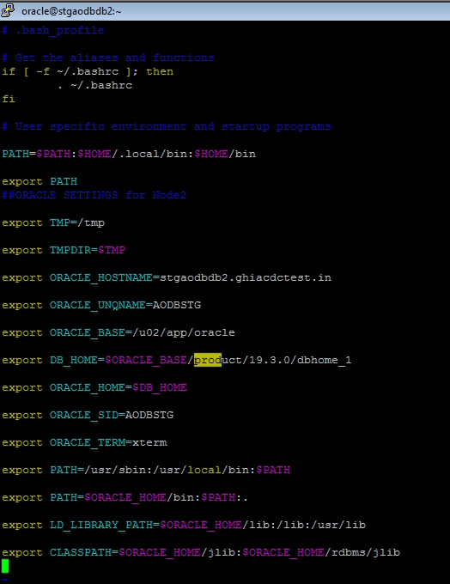

15)switch to grid user in secondary node and open .bash_profile

Copy the below commands

# .bash_profile

# Get the aliases and functions

if [ -f ~/.bashrc ]; then

. ~/.bashrc

fi

# User specific environment and startup programs

PATH=$PATH:$HOME/.local/bin:$HOME/bin

export PATH

##GRID SETTINGS for Node2

export TMP=/tmp

export TMPDIR=$TMP

export ORACLE_HOSTNAME=stgaodbdb2.ghiacdctest.in

export ORACLE_BASE=/u01/app/oracle

export ORACLE_HOME=/u01/app/grid/19.3.0/grid_home1

export GRID_BASE=/u01/app/oracle

export GRID_HOME=/u01/app/grid/19.3.0/grid_home1

export ORACLE_SID=+ASM2

export ORACLE_TERM=xterm

export PATH=/usr/sbin:/usr/local/bin:$PATH

export PATH=$ORACLE_HOME/bin:$PATH

export LD_LIBRARY_PATH=$ORACLE_HOME/lib:/lib:/usr/lib

export CLASSPATH=$ORACLE_HOME/jlib:$ORACLE_HOME/rdbms/jlib

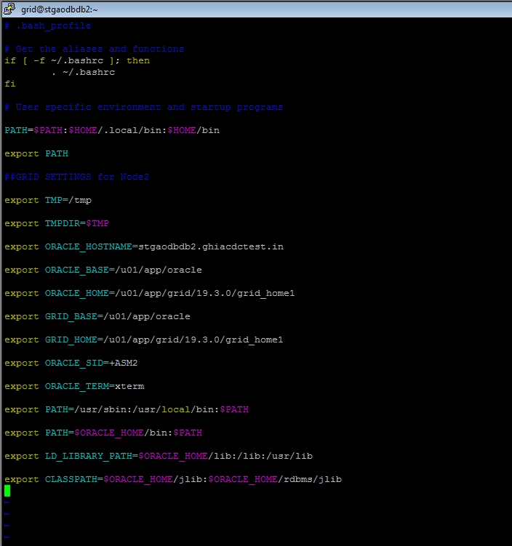

16) Now we need to create oracle asm disks

Enter the command lsblk

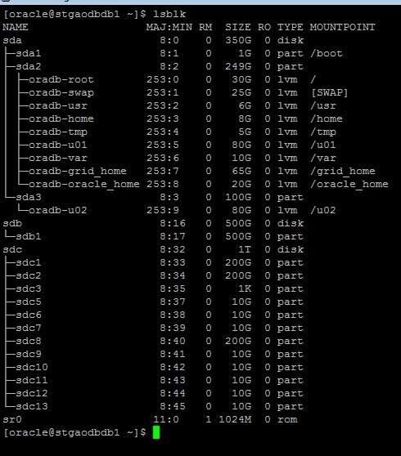

Enter below commands

oracleasm createdisk OCR1 /dev/sdc9;

oracleasm createdisk OCR2 /dev/sdc10;

oracleasm createdisk OCR3 /dev/sdc11;

oracleasm createdisk OCR4 /dev/sdc12;

oracleasm createdisk OCR5 /dev/sdc13;

oracleasm createdisk REDO1 /dev/sdc5;

oracleasm createdisk REDO2 /dev/sdc6;

oracleasm createdisk REDO3 /dev/sdc7;

oracleasm createdisk FRA /dev/sdc8;

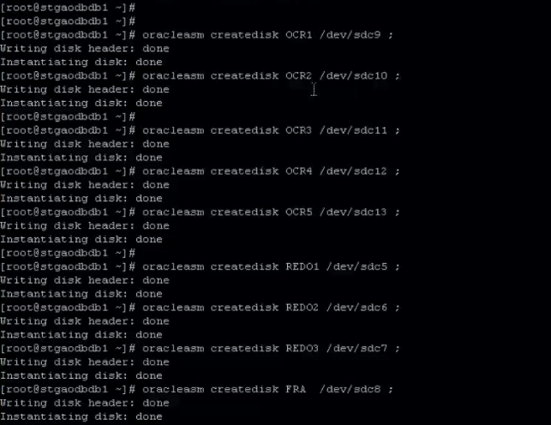

For RAC installation datafiles will not be present in oracle_home they will be present in shared disks

17)Now we need to check the disks which we created are present or not

oracleasm scandisks;

oracleasm listdisks;

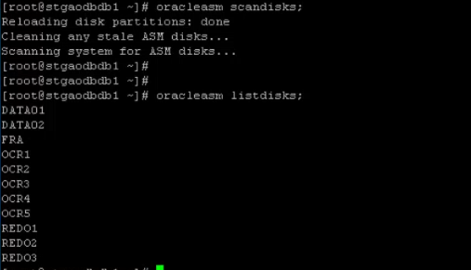

18)login to other node with oracle user and enter the command oracleasm listdisks

We will get the same data as above.no need to create again

19)check the same command with both oracle and grid users in both the servers

If we get any error like permission denied, please follow below steps

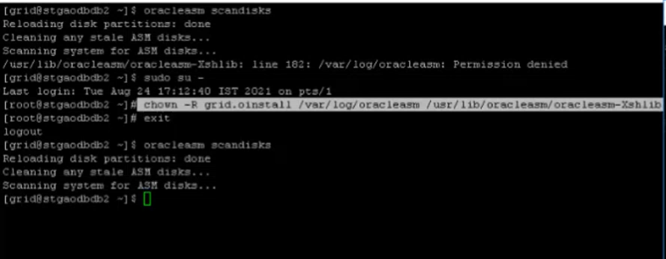

20)check ns lookup in both the servers

